Design a Web Page in HTML to perform
i) Hyperlink
ii)Navigation
iii)Multimedia
==============================================================================
COMMAND:
INDEX.HTML
<!DOCTYPE html>
<html>
<head>
<title>Hyperlink, Navigation, Multimedia</title>
</head>
<body>

<h2>Navigation</h2>
<a href="home.html">Home</a> |
<a href="hyperlink1.html">Hyperlinks</a> |
<a href="media1.html">Multimedia</a>

<hr>

<h1 id="home">Welcome to My Web Page</h1>
<p>This page shows Hyperlinks, Navigation, and Multimedia using ONLY HTML.</p>

<hr>

<h2 id="links">Hyperlinks</h2>
<p>External Link:</p>
<a href="https://www.google.com">Visit Google</a>

<p>Internal Link:</p>
<a href="D:\1400\ADMIN\video.mp4">Go to Multimedia Section</a>

<hr>

<h2 id="media">Multimedia Section</h2>

<h3>Image:</h3>
<img src="image.jpg" width="300" height="200" alt="LOK SABHA">

<h3>Audio:</h3>
<audio controls>
<source src="song.mp3" type="audio/mp3">
</audio>

<h3>Video:</h3>
<video width="320" height="240" controls>
<source src="video.mp4" type="video/mp4">
</video>

</body>
</html>

HOME.HTML
<DOCTYPEhtml>
<head>
<title>home page</title>
</head>
<body>
<h1> Welcom to My Home Page (Under Progress) </h1>
</body>
</html>

HYPERLINK1.HTML
<DOCTYPEhtml>
<head>
<title>hyperlink page</title>
</head>
<body>
<h1> Welcom to My Hyperlink Page </h1>
<hr>
<h2 id="links">Hyperlinks</h2>
<p>External Link:</p>
<a href="https://www.google.com">Visit Google</a>

<p>Internal Link:</p>
<a href="D:\1400\ADMIN\video.mp4">Go to Multimedia Section</a>
</body>
</html>

MEDIA1.HTML
<DOCTYPEhtml>
<head>
<title>multimedia page</title>
</head>
<body>
<h1> Welcom to My Multimedia Page (Under Progress)</h1>
</body>
</html>

OUTPUT:

INDEX.HTML
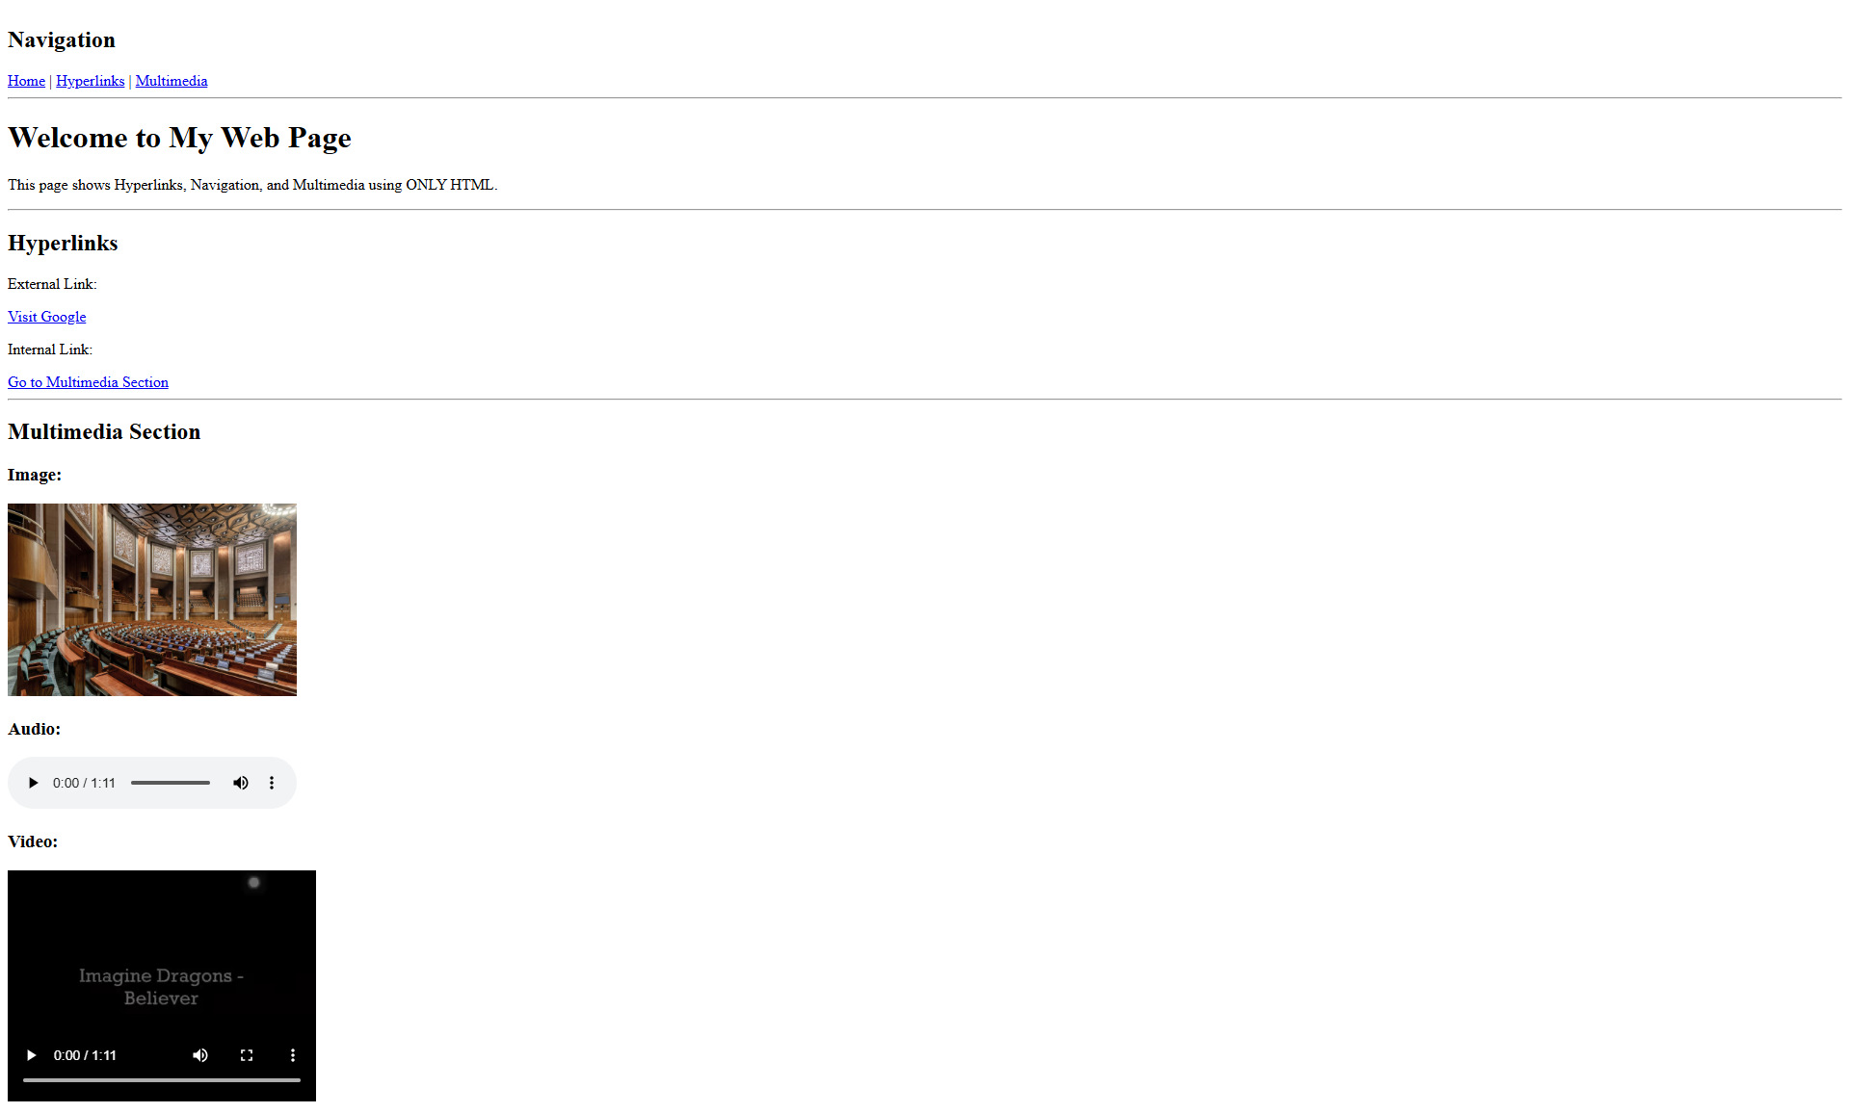
HOME.HTML

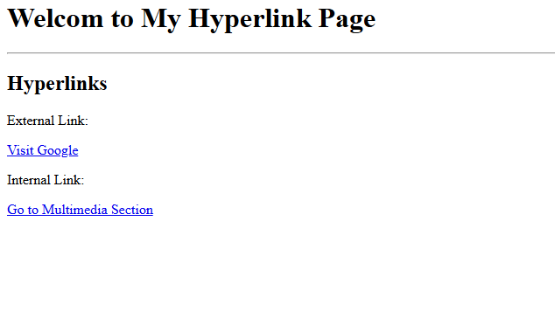
HYPERLINK1.HTML

MEDIA1.HTML

